HC-05 and HC-06 Bluetooth Module
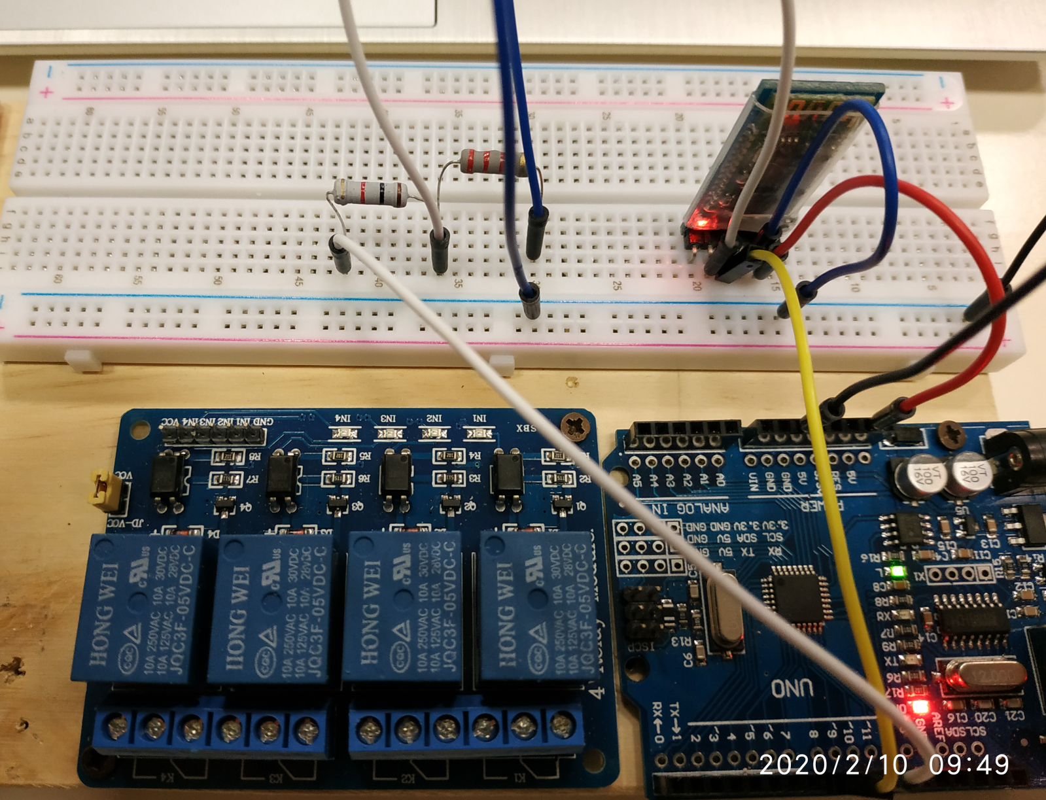

#include <SoftwareSerial.h>
SoftwareSerial BTserial(8, 9); // RX | TX

const long baudRate = 9600;
char c=' ';
boolean NL = true;

void setup()
{
Serial.begin(9600);
BTserial.begin(baudRate);
Serial.print("BTserial started at ");
Serial.println(baudRate);
}

void loop()
{
// Read from the Bluetooth module and send to the Arduino Serial Monitor
if (BTserial.available())
{
c = BTserial.read();
Serial.write(c);
}

// Read from the Serial Monitor and send to the Bluetooth module
if (Serial.available())
{
c = Serial.read();
BTserial.write(c);

// Echo the user input to the main window. The ">" character indicates the user entered text.
if (NL) { Serial.print(">"); NL = false; }
Serial.write(c);
if (c==10) { NL = true; }
}

}

